TPS561201 5V

STM32F429:

3.312V 0.083A

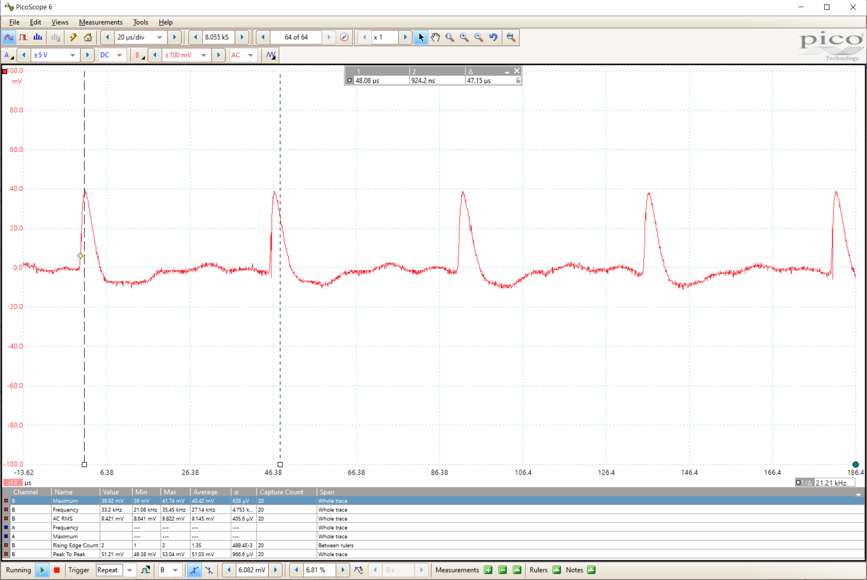

No ST-Link

LM

2675 5V

3.306V 0.63A

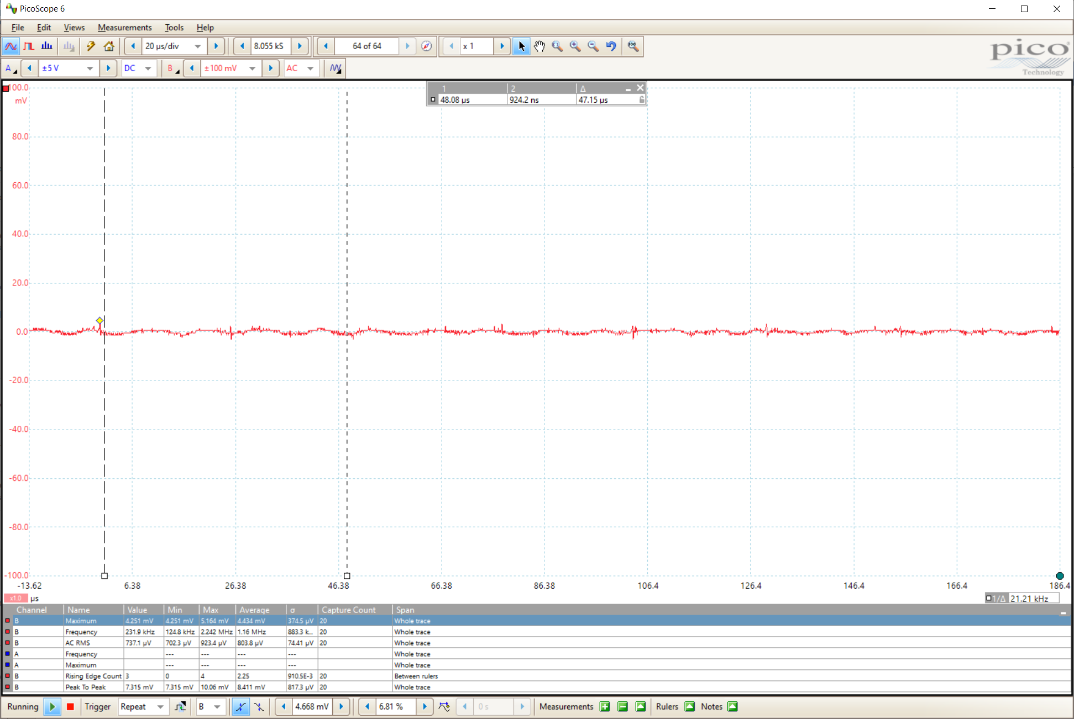

2675 3.3V

Digital Rail: 3.379V 0.062A

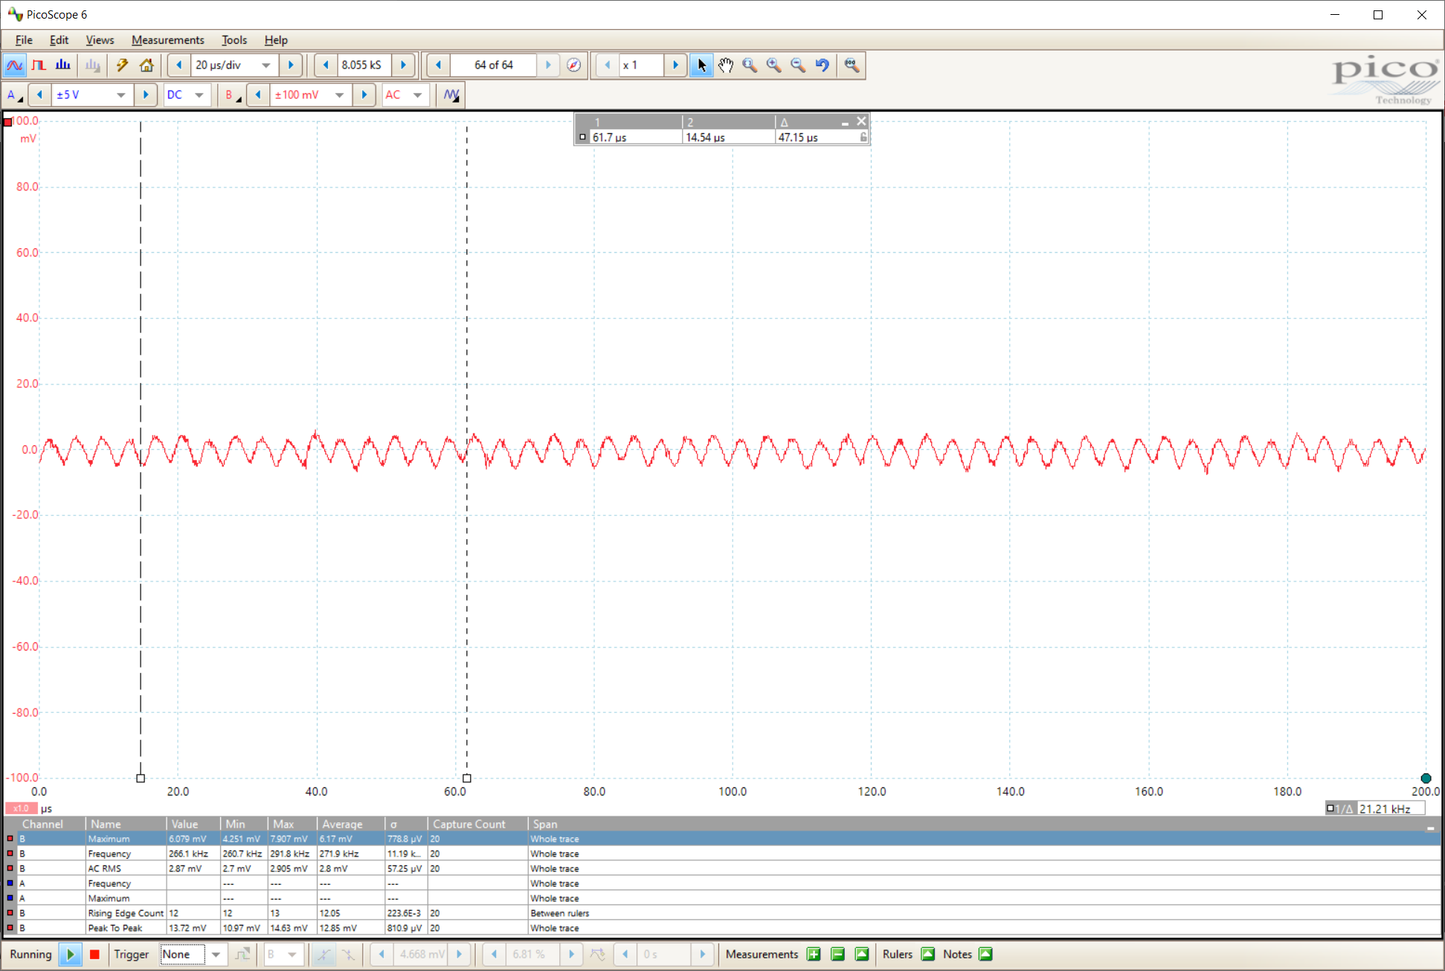

Analog Rail: 3.318V

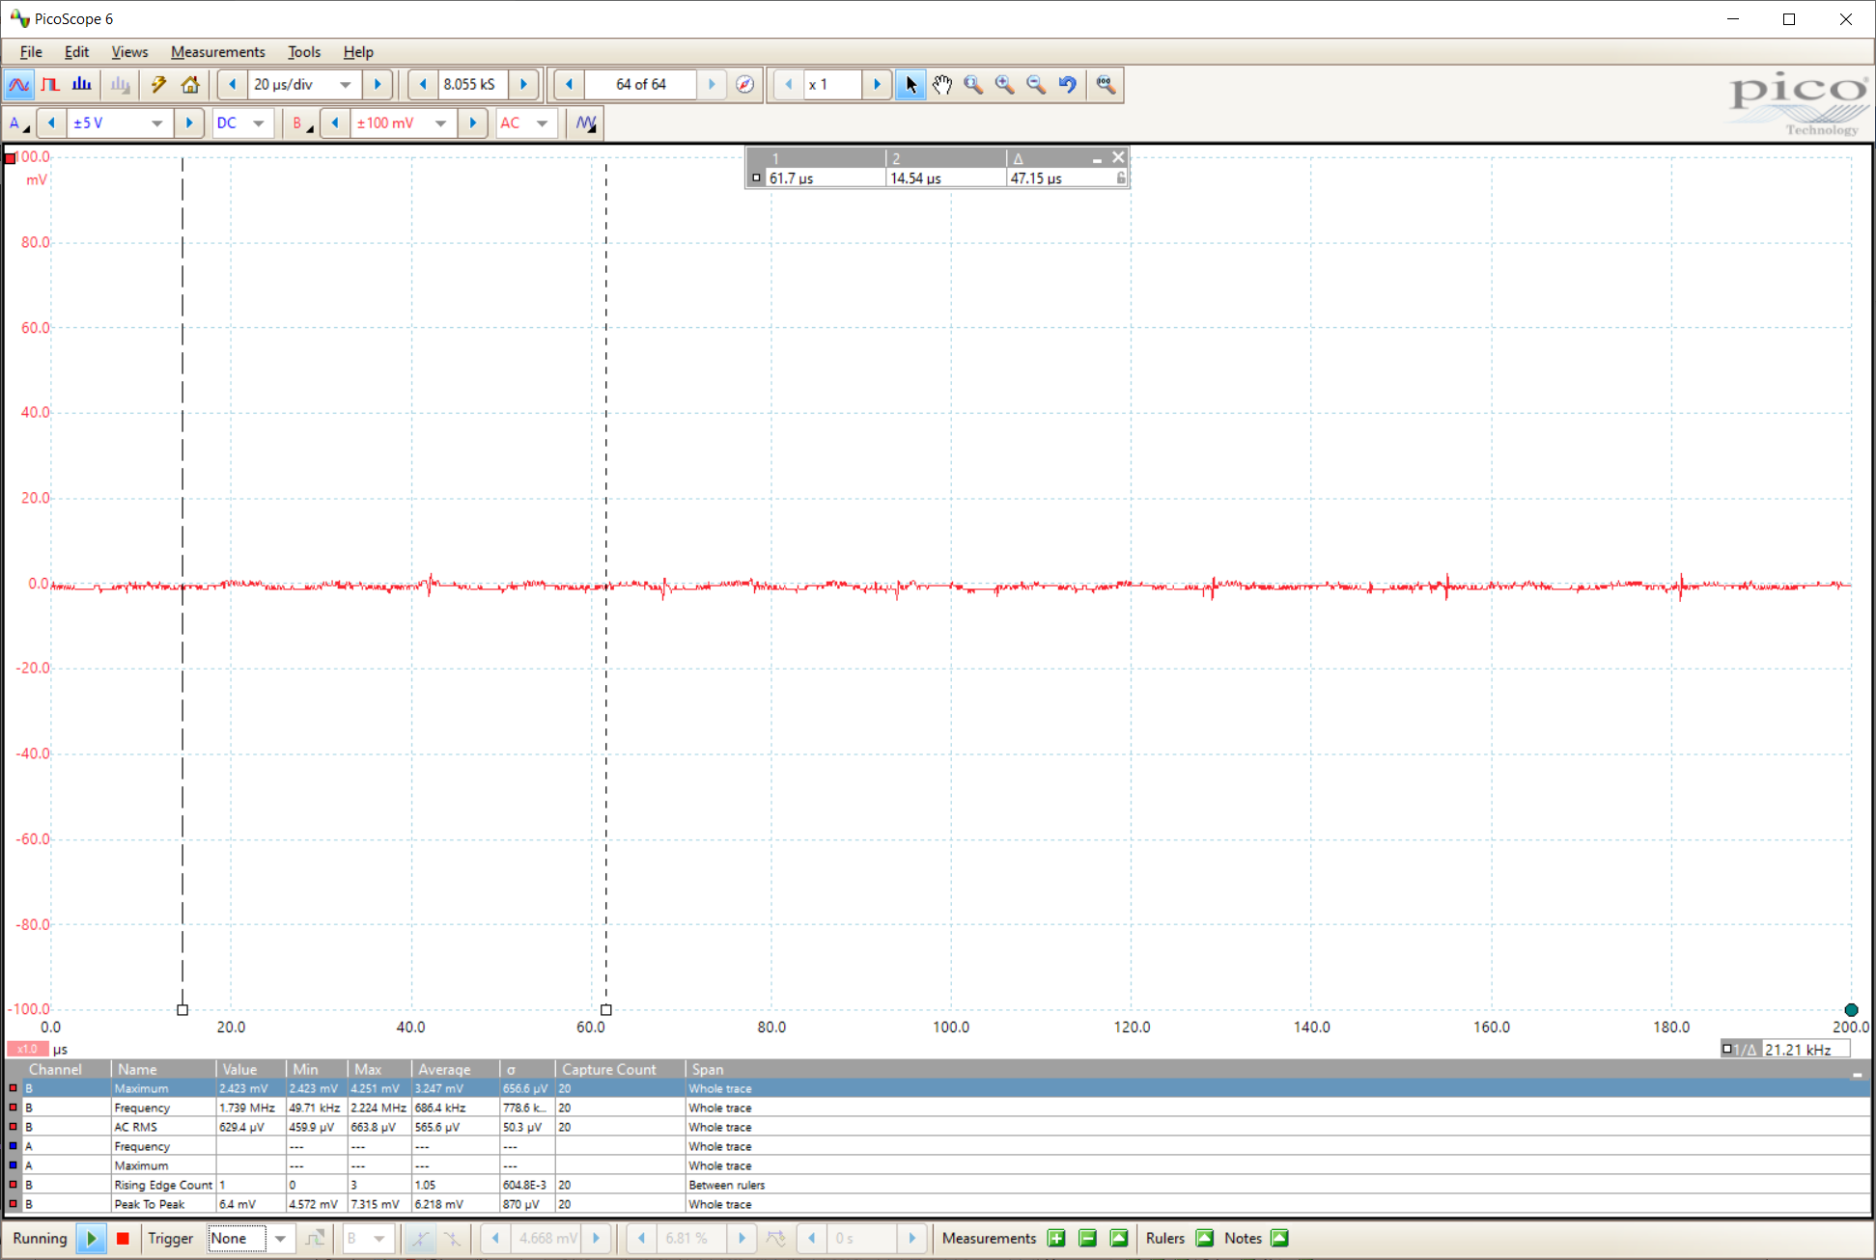

STM32H743 Original (No switching)

3.326V 0.132A

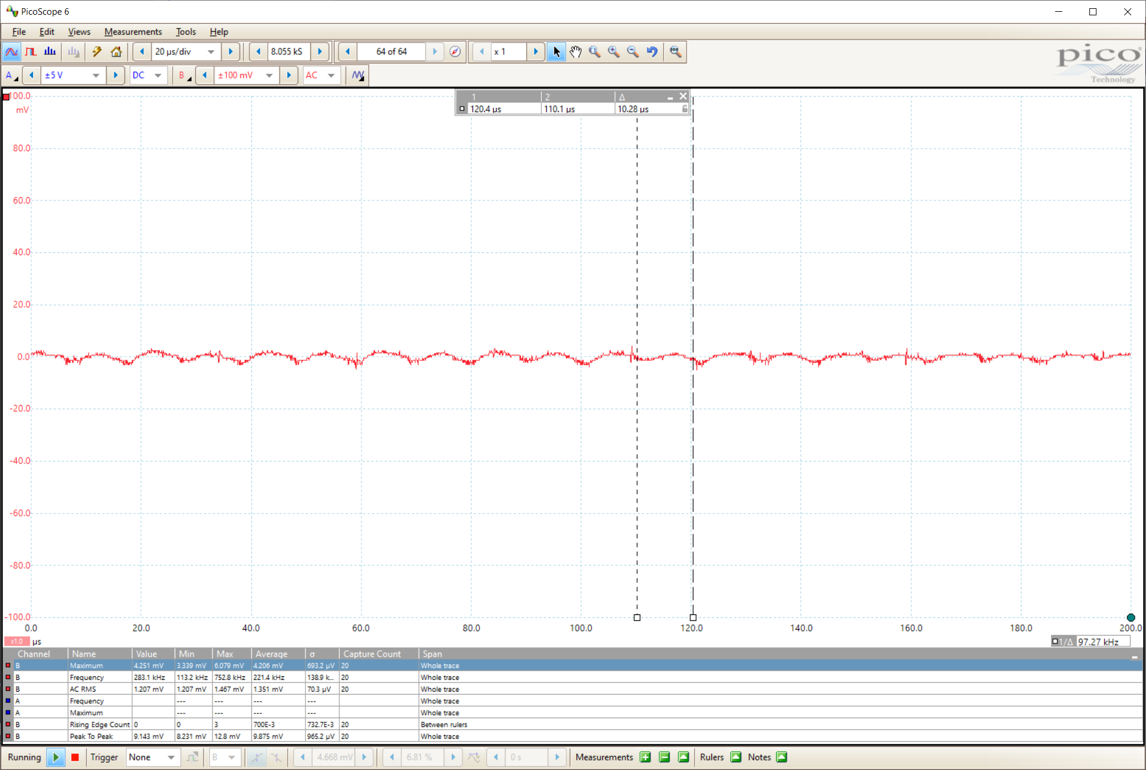

STM32H743 (LM2675)

3.307V 0.073A

